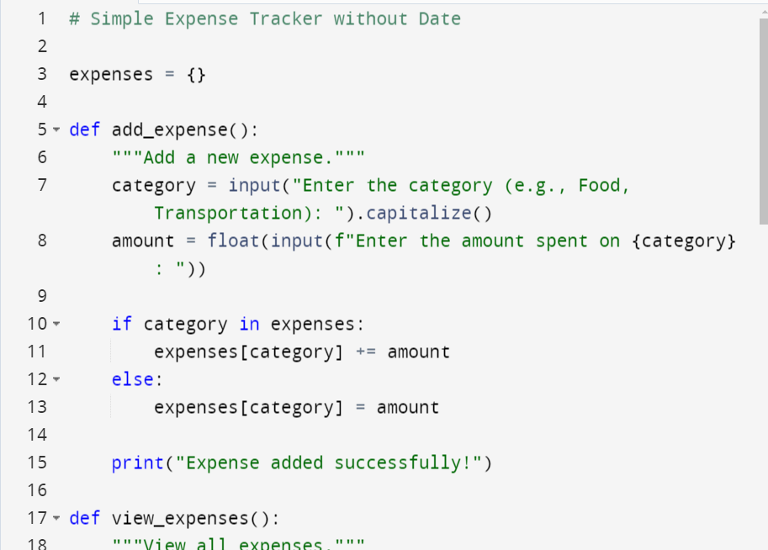

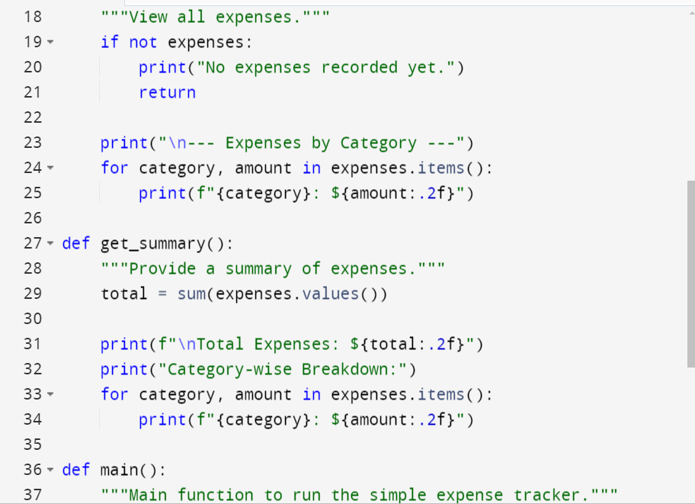

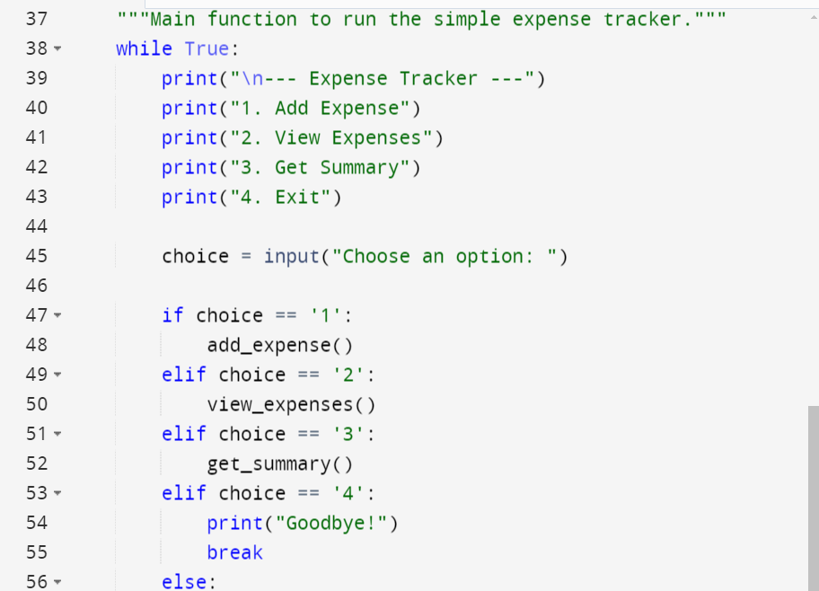

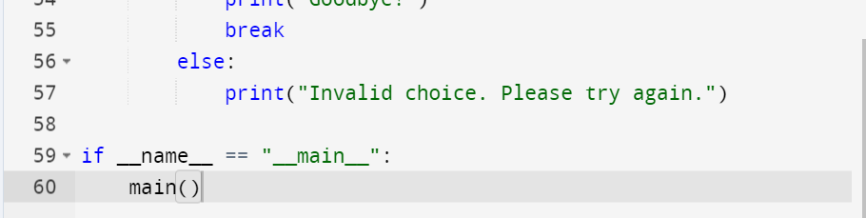

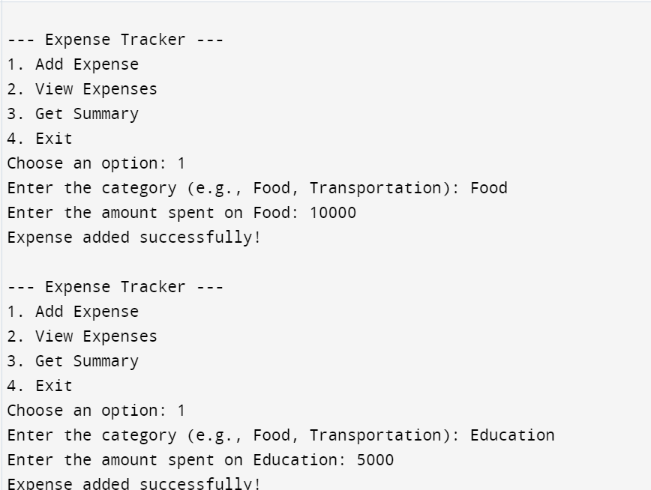

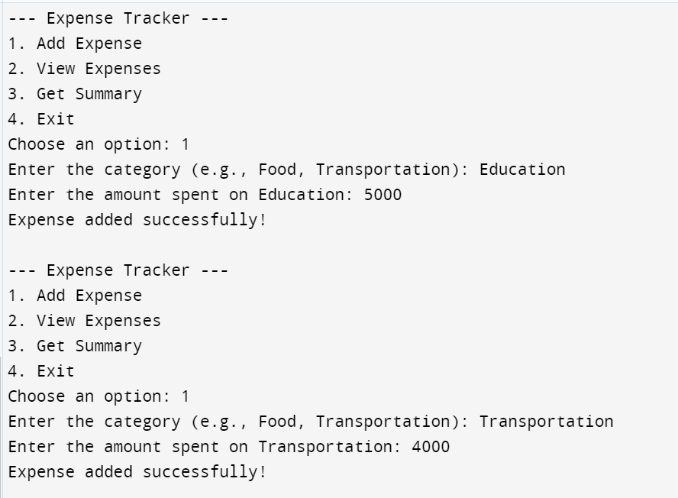

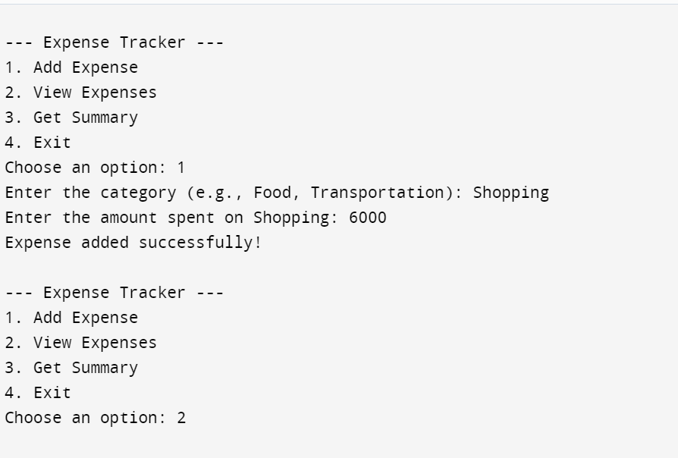

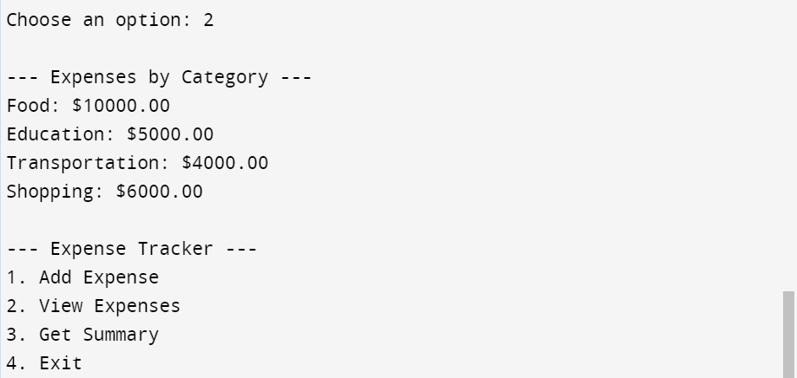

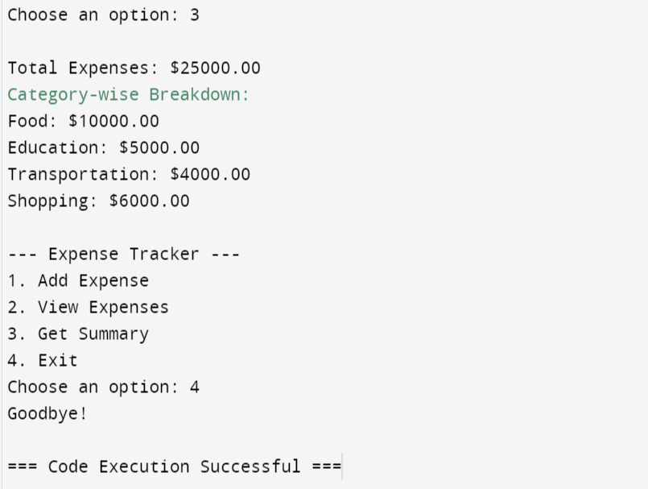

# Simple Expense Tracker without Date

expenses = {}

def add_expense():

"""Add a new expense."""

category = input("Enter the category (e.g., Food, Transportation): ").capitalize()

amount = float(input(f"Enter the amount spent on {category}: "))

if category in expenses:

expenses[category] += amount

else:

expenses[category] = amount

print("Expense added successfully!")

def view_expenses():

"""View all expenses."""

if not expenses:

print("No expenses recorded yet.")

return

print("\n--- Expenses by Category ---")

for category, amount in expenses.items():

print(f"{category}: ${amount:.2f}")

def get_summary():

"""Provide a summary of expenses."""

total = sum(expenses.values())

print(f"\nTotal Expenses: ${total:.2f}")

print("Category-wise Breakdown:")

for category, amount in expenses.items():

print(f"{category}: ${amount:.2f}")

def main():

"""Main function to run the simple expense tracker."""

while True:

print("\n--- Expense Tracker ---")

print("1. Add Expense")

print("2. View Expenses")

print("3. Get Summary")

print("4. Exit")

choice = input("Choose an option: ")

if choice == '1':

add_expense()

elif choice == '2':

view_expenses()

elif choice == '3':

get_summary()

elif choice == '4':

print("Goodbye!")

break

else:

print("Invalid choice. Please try again.")

if __name__ == "__main__":

main()